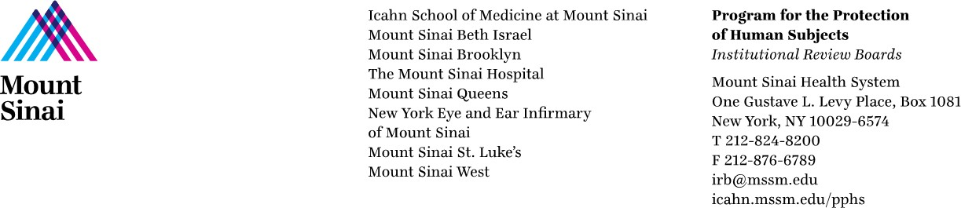

Re: NIH Policy on the Use of a Single Institutional Review Board of Record for Multi-Site Research

The Program for the Protection of Human subjects (PPHS) at the Icahn School of Medicine at Mount Sinai (ISMMS) understands that the new NIH Policy on the Use of a Single Institutional Review Board of Record for Multi-Site Research establishes the expectation that all sites participating in multi-site studies, involving non-exempt human subjects research and funded by the National Institutes of Health (NIH), will use a single Institutional Review Board (sIRB) to conduct the ethical review required by the Department of Health and Human Services regulations for the Protection of Human Subjects.

When ISMMS will be a relying site (regardless of whether ISMMS is the prime awardee), the ISMMS IRB agrees to cooperate with the Single IRB plan when the Reviewing IRB is one of the following:
- accredited and utilizing the SmartIRB Master Common Reciprocal Institutional Review Board Authorization Agreement (SmartIRB Agreement), or
- a non-accredited CTSA hub with no OHRP/FDA warning letters utilizing the SmartIRB Agreement)
- an external IRB with which ISMMS already has an existing master agreement.

